**Classification of Arrhythmia by Using Deep Learning with 2-D ECG Spectral Image Representation**

#### **Introduction**

Cardiac disorder may cause a severe warning to public health, and in most cases, some arrhythmias can cause severe damage or death. According to the data provided by World Health Organization (WHO) [1], approximately 25.6 million people died due to cardiovascular disease in 2020. Electrocardiogram (ECG) test is used as a diagnostic tool in healthcare institutes. The electrodes attached to the patients’ body surface can record the heart’s electrical signal over time. Figure [1](https://www.hindawi.com/journals/complexity/2021/9919588/fig1/) shows the ECG leads attached to the human’s body surface to get the heart’s electrical signals.

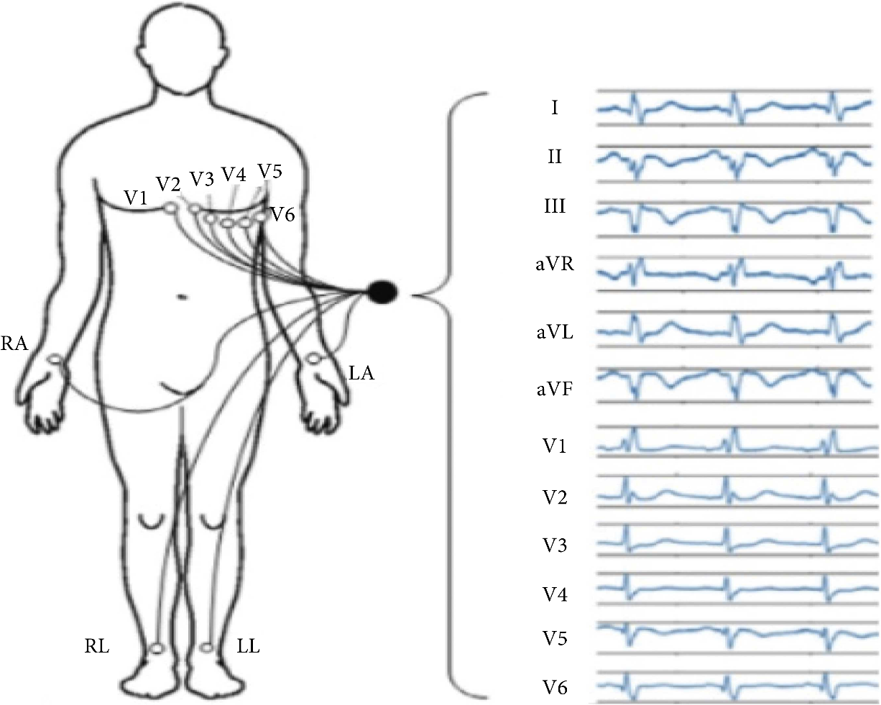

Fig.1.1

The healthcare professionals manually diagnose the patient heart condition by interpreting the ECG image. In the advent of technology, several automatic diagnostic tools are developed for arrhythmias classification and detection to assist doctors. PCGs and ECGs are used to diagnose arrhythmia classification. PCG (also known as heart sound auscultation) is commonly listened to or recorded by practitioners through a stethoscope to identify heart irregularities.

For this reason, heartbeats have been critically studied to make a diagnosis [2–5]. Khan et al. [6] provided a very thorough introduction of related studies in the problem domain and proposed a technique based on DNN, for the classification of three kinds of arrhythmia beats. CNN is considered a state-of-the-art tool for the classification of arrhythmia, and it has been studied with several variations such as 1-dimensional, 2-dimensional, or the combination of both [7, 8]. According to Xiao et al. [7], a novel arrhythmia classification technique comprises three phases: preprocessing, 1-dimensional CNN architecture based on clique blocks with bidirectional connections between layers and transition blocks with attention mechanism, and majority voting to predict the final result. Experiments were performed on PhysioNet/CinC 2016 database.

However, low-frequency noise considerations recorded in arrhythmia beats are ignored, and 2-dimensional acoustical representation requires additional computation, which cannot be accomplished without hyperparameters. Similarly, Noman et al. [8] proposed a framework based on 1-dimensional CNN for direct feature learning from raw arrhythmia beats and 2-dimensional CNN, which takes 2-dimensional time-frequency feature maps.

In the state-of-the-art studies [4–8], automated system which predicts high accuracy results is developed for arrhythmia detection but still not adoptable by healthcare professionals.

The primary concerns which affect the success of the developed arrhythmia detection systems are (i) manual features selection, (ii) techniques used for features extraction, and (iii) algorithm used for classification and the most important is the use of imbalanced data for classification. The automated arrhythmia detection required the feature extraction of ECG images that required domain knowledge.

In the last few years, deep learning-based systems are being recognized as a tool in healthcare institutes that have capabilities to automatically extract high-level abstract features, avoiding laborious manual feature design. A deep neural network is configured in the same fashion as the human brain works. A single neuron understands and recognizes the pattern based on the logical principles among different components. The proposed work’s major concern is to review the recent trends of arrhythmia classification techniques and enlist the limitation and future requirements. This study can help the researcher get a deeper understanding of arrhythmia classification and the deep learning methods used to develop automated systems.

The reminder of the paper is organized into six sections. The methods used in the proposed study are discussed in Section [2](https://www.hindawi.com/journals/complexity/2021/9919588/#sec2), and the research community’s related work in the current field is presented in Section [3](https://www.hindawi.com/journals/complexity/2021/9919588/#sec3) with a close comparison. Recent trends of arrhythmia classification and limitation of the current study are discussed in Sections [4](https://www.hindawi.com/journals/complexity/2021/9919588/#sec4) and [5](https://www.hindawi.com/journals/complexity/2021/9919588/#sec5), respectively. The paper is concluded in Section [6](https://www.hindawi.com/journals/complexity/2021/9919588/#sec6).

1. **Literature survey**

Based on the selection criteria, the fifty technical articles on arrhythmia classification are examined which are published between January 2010 to January 2020. The selected articles are critically examined, and if any selected articles are available on more than one scientific repository or database, it is considered only once.

The different kinds of methodologies, classification algorithms with their accuracy results, and optimization methods used for arrhythmia classification are reviewed from the selected articles. Table [2](https://www.hindawi.com/journals/complexity/2021/9919588/tab2/) shows the literature survey on arrhythmia classification techniques that are used in this study.

The authors present the recent trends for arrhythmia classification, the techniques used for features extraction, and the variation of deep neural networks. The study is beneficial for the scientific community to select the arrhythmia classification techniques as per their desires. Table [3](https://www.hindawi.com/journals/complexity/2021/9919588/tab3/) identified the latest trends from recently proposed studies for arrhythmia classification.

**3.Recent Trends in Arrhythmia Classification**

The primary objective of this study is to present the techniques used in arrhythmia classification with a publicly available ECG database used in deep/machine learning algorithms. The selected state-of-the-art research studies show the most common methods used for arrhythmia classification and their accuracy results. The accuracy results represent the learning algorithm’s success rate that how well the machine was trained to identify the ground truth automatically.

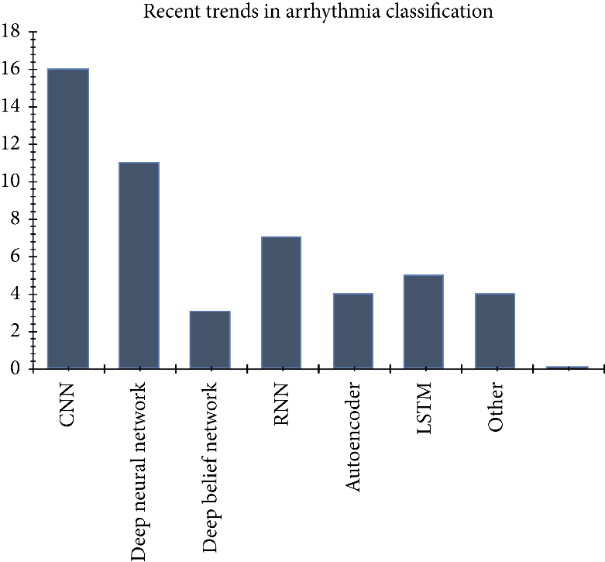

Fig.3.1

The primary objective of this study is to help the scientific community to list the methodologies used in arrhythmia classification with prediction results that researchers can easily select the techniques as per their requirements. Figure [3](https://www.hindawi.com/journals/complexity/2021/9919588/fig3/) shows the statistics of most adopted arrhythmia classification techniques used in selected studies.

**References**

1. Mc Namara, K.; Alzubaidi, H.; Jackson, J.K. Cardiovascular disease as a leading cause of death: How are pharmacists getting involved? Integr. Pharm. Res. Pract. 2019, 8, 1.

2. Lackland, D.T.; Weber, M.A. Global burden of cardiovascular disease and stroke: hypertension at the core. Can. J. Cardiol. 2015, 31, 569–571.

3. Mustaqeem, A.; Anwar, S.M.; Majid, M. A modular cluster based collaborative recommender system for cardiac patients. Artif. Intell. Med. 2020, 102, 101761.

4. Irmakci, I.; Anwar, S.M.; Torigian, D.A.; Bagci, U. Deep Learning for Musculoskeletal Image Analysis. arXiv Prepr. 2020, arXiv:2003.00541.

5. Anwar, S.M.; Majid, M.; Qayyum, A.; Awais, M.; Alnowami, M.; Khan, M.K. Medical image analysis using convolutional neural networks: A review. J. Med. Syst. 2018, 42, 226.

6. Gu, J.; Wang, Z.; Kuen, J.; Ma, L.; Shahroudy, A.; Shuai, B.; Liu, T.; Wang, X.; Wang, G.; Cai, J.; et al. Recent advances in convolutional neural networks. Pattern Recognit. 2018, 77, 354–377.

7. Wu, Y.; Yang, F.; Liu, Y.; Zha, X.; Yuan, S. A comparison of 1-D and 2-D deep convolutional neural networks in ECG classification. arXiv Prepr. 2018, arXiv:1810.07088.

8. Zhao, J.; Mao, X.; Chen, L. Speech emotion recognition using deep 1D & 2-D CNN LSTM networks. Biomed. Signal Process. Control 2019, 47, 312–323.

9. Ortega, S.; Fabelo, H.; Iakovidis, D.K.; Koulaouzidis, A.; Callico, G.M. Use of hyperspectral/multispectral imaging in gastroenterology. Shedding some–different–light into the dark. J. Clin. Med. 2019, 8, 36.

10. Feng, Y.-Z.; Sun, D.-W. Application of Hyperspectral Imaging in Food Safety Inspection and Control: A Review. Crit. Rev. Food Sci. Nutr. 2012, 52, 1039–1058.

11. Lorente, D.; Aleixos, N.; Gómez-Sanchis, J.; Cubero, S.; García-Navarrete, O.L.; Blasco, J. Recent Advances and Applications of Hyperspectral Imaging for Fruit and Vegetable Quality Assessment. Food Bioprocess Technol. 2011, 5, 1121–1142.

12. Tatzer, P.; Wolf, M.; Panner, T. Industrial application for inline material sorting using hyperspectral imaging in the NIR range. Real-Time Imaging 2005, 11, 99–107.

13. Kubik, M. Chapter 5 Hyperspectral Imaging: A New Technique for the Non-Invasive Study of Artworks. Phys. Tech. Study Art Archaeol. Cult. Herit. 2007, 2, 199–259.

14. Hassan, H.; Bashir, A. K.; Abbasi, R.; Ahmad, W.; Luo, B. Single image defocus estimation by modified gaussian function. Trans. Emerg. Telecommun. Technol. 2019, 30, 3611.

15. Ahmad, M.; Bashir, A.K.; Khan, A.M. Metric similarity regularizer to enhance pixel similarity performance for hyperspectral unmixing. Optik 2017, 140, 86–95.

16. Salem, M.; Taheri, S.; Yuan, J.S. ECG arrhythmia classification using transfer learning from 2-dimensional deep CNN features. In Proceedings of the 2018 IEEE Biomedical Circuits and Systems Conference (BioCAS), Cleveland, Ohio, USA, 17–19 October 2018; IEEE: 2018, pp. 1–4.

17. Mustaqeem, A.; Anwar, S.M.; Khan, A.R.; Majid, M. A statistical analysis based recommender model for heart disease patients. Int. J. Med. Inform. 2017, 108, 134–145.

18. Anwar, S.M.; Gul, M.; Majid, M.; Alnowami, M. Arrhythmia Classification of ECG Signals Using Hybrid Features. Comput. Math. Methods Med. 2018, <https://doi.org/10.1155/2018/1380348>.

19. Mustaqeem, A.; Anwar, S.M.; Majid, M. Multiclass classification of cardiac arrhythmia using improved feature selection and SVM invariants. Comput. Math. Methods Med. 2018, <https://doi.org/10.1155/2018/7310496>.

20. Mustaqeem, A.; Anwar, S.M.; Majid, M.; Khan, A.R. Wrapper method for feature selection to classify cardiac arrhythmia. In Proceedings of the 2017 39th Annual International Conference of the IEEE Engineering in Medicine and Biology Society (EMBC), Jeju Island, Korea, 11–15 July 2017; IEEE: 2017, pp. 3656–3659.

21. Minami, K. I.; Nakajima, H.; Toyoshima, T. Real-time discrimination of ventricular tachyarrhythmia with Fourier-transform neural network. IEEE Trans. Biomed. Eng. 1999, 46, 179–185.

22. Coast, D.A.; Stern, R.M.; Cano, G.G.; Briller, S.A. An approach to cardiac arrhythmia analysis using hidden markov models. IEEE Trans. Biomed. Eng. 1990, 37, 826–836.

23. Osowski, S.; Hoai, L. T.; Markiewicz, T. Support vector machine based expert system for reliable heartbeat recognition. IEEE Trans. Biomed. Eng. 2004, 51, 582–589.

24. Willems, J. L.; Lesaffre, E. Comparison of multigroup logistic and linear discriminant ecg and vcg classification. J. Electrocardiol. 1987, 20, 83–92.

25. Hu, Y.H.; Tompkins, W.J.; Urrusti, J.L.; Afonso, V.X. Applications of artificial neural networks for ECG signal detection and classification. J. Electrocardiol. 1993,

26, 66–73. 26. Trahanias, P.; Skordalakis, E. Syntactic pattern recognition of the ECG. IEEE Trans. Pattern Anal. Mach. Intell. 1990, 12, 648–657.

27. Inan, O.T.; Giovangrandi, L.; Kovacs, G.T. Robust neural-network-based classification of premature ventricular contractions using wavelet transform and timing interval features. IEEE Trans. Biomed. Eng. 2006, 53, 2507–2515. Remote Sens. 2020, 12, 1685 14 of 15

28. Hu, Y.H.; Palreddy, S.; Tompkins, W.J. A patient-adaptable ECG beat classifier using a mixture of experts approach. IEEE Trans. Biomed. Eng. 1997, 44, 891–900.

29. Dehan, L.; Guanggui, X.U.; Yuhua, Z.; Hosseini, H.G. Novel ECG diagnosis model based on multi-stage artificial neural networks. Chin. J. Sci. Instrum. 2008, 29, 27.

30. Ceylan, R.; Ozbay, Y. Comparison of FCM, PCA and WT techniques for classification ECG arrhythmias using artificial neural network. Expert Syst. Appl. 2007, 33, 286–295.

31. Polat, K.; Günes, S. Breast cancer diagnosis using least square support vector machine. Digit. Signal Process. 2007, 17, 694–701.

32. Dreiseitl, S.; Ohno-Machado, L.; Kittler, H.; Vinterbo, S.; Billhardt, H.; Binder, M. A comparison of machine learning methods for the diagnosis of pigmented skin lesions. J. Biomed. Inform. 2001, 34, 28–36.

33. Shafiq, M.; Yu, X.; Bashir, A. K.; Chaudhry, H. N.; Wang, D. A machine learning approach for feature selection traffic classification using security analysis. J. Supercomput. 2018, 74, 4867–4892.

34. Bashir, A.K.; Arul, R.; Basheer, S.; Raja, G.; Jayaraman, R.; Qureshi, N.M.F. An optimal multitier resource allocation of cloud RAN in 5G using machine learning. Trans. Emerg. Telecommun. Technol. 2019, 30, 3627.

35. Kononenko, I. Machine learning for medical diagnosis: History, state of the art and perspective. Artif. Intell. Med. 2001, 23, 89–109.

36. Ecar, A. Recommended practice for testing and reporting performance results of ventricular arrhythmia detection algorithms. Assoc. Adv. Med. Instrum. 1987, 69.

37. Huertas-Fernandez, I.; Garcia-Gomez, Garcia-Solis, F.J.D.; Benitez-Rivero, S.; Marin-Oyaga, V.A.; Jesus, S.; Mir, P. Machine learning models for the differential diagnosis of vascular parkinsonism and Parkinson’s disease using [123 I] FP-CIT SPECT. Eur. J. Nucl. Med. Mol. Imaging 2015, 42, 112–119.

38. Salvatore, C.; Cerasa, A.; Battista, P.; Gilardi, M.C.; Quattrone, A.; Castiglioni, I. Magnetic resonance imaging biomarkers for the early diagnosis of Alzheimer’s disease: A machine learning approach. Front. Neurosci. 2015, 9, 307.

39. Kiranyaz, S.; Ince, T.; Gabbouj, M. Real-time patient-specific ECG classification by 1-D convolutional neural networks. IEEE Trans. Biomed. Eng. 2015, 63, 664–675.

40. Rajpurkar, P.; Hannun, A.Y.; Haghpanahi, M.; Bourn, C.; Ng, A.Y. Cardiologist-level arrhythmia detection with convolutional neural networks. arXiv Prepr. 2017, arXiv:1707.01836.

41. Acharya, U.R.; Oh, S.L.; Hagiwara, Y.; Tan, J.H.; Adam, M.; Gertych, A.; San Tan, R. A deep convolutional neural network model to classify heartbeats. Comput. Biol. Med. 2017, 89, 389–396.

42. Chen, J.; Valehi, A.; Razi, A. Smart Heart Monitoring: Early Prediction of Heart Problems Through Predictive Analysis of ECG Signals. IEEE Access 2019, 7, 120831–120839.

43. Lee, S.C. Using a translation-invariant neural network to diagnose heart arrhythmia. In Advances in Neural Information Processing Systems, Morgan Kaufmann, USA; 1990; pp. 240–247.

44. De Chazal, P.; Reilly, R.B. A patient-adapting heartbeat classifier using ECG morphology and heartbeat interval features. IEEE Trans. Biomed. Eng. 2015, 53, 2535–2543.

45. Xiong, Z.; Stiles, M.K.; Zhao, J. Robust ECG signal classification for detection of atrial fibrillation using a novel neural network. In Proceedings of the 2017 Computing in Cardiology (CinC), Rennes, France, 24–27 September 2017; IEEE, 2017; pp. 1–4.

46. Clevert, D. A.; Unterthiner, T.; Hochreiter, S. (2015). Fast and accurate deep network learning by exponential linear units (elus). arXiv preprint arXiv:1511.07289.

47. Li, D.; Zhang, J.; Zhang, Q.; Wei, X. Classification of ECG signals based on 1D convolution neural network. In Proceedings of the 2017 IEEE 19th International Conference on e-Health Networking, Applications and Services (Healthcom), Dalian, China, 12–15 October 2017; IEEE: 2017; pp. 1–6.

48. Jun, T.J.; Nguyen, H.M.; Kang, D.; Kim, D.; Kim, D.; Kim, Y.H. ECG arrhythmia classification using a 2-D convolutional neural network. arXiv Prepr. 2018, arXiv:1804.06812.

49. Mohanty, M.D.; Mohanty, B.; Mohanty, M.N. R-peak detection using efficient technique for tachycardia detection. In Proceedings of the 2017 2nd International Conference on Man and Machine Interfacing (MAMI), Bhubaneswar, India, 21–23 December 2017; IEEE: 2017; pp. 1—5.

50. Moody, G.B.; Mark, R.G. The impact of the MIT-BIH arrhythmia database. IEEE Eng. Med. Biol. Mag. 2001, 20, 45–50.

51. Abadi, M.; Agarwal, A.; Barham, P.; Brevdo, E.; Chen, Z.; Citro, C.; Corrado, G.S.; Davis, A.; Dean, J.; Devin, M.; et al. Tensorflow: Large-scale machine learning on heterogeneous distributed systems. arXiv Prepr. 2016, arXiv:1603.04467.

52. Übeyli, E.D. Combining recurrent neural networks with eigenvector methods for classification of ECG beats. Digit. Signal Process. 2009, 19, 320–329.

53. Dutta, S.; Chatterjee, A.; Munshi, S. Correlation technique and least square support vector machine combine for frequency domain based ECG beat classification. Med. Eng. Phys. 2010, 32, 1161–1169.

54. Kumar, R.G.; Kumaraswamy, Y.S. Investigating cardiac arrhythmia in ECG using random forest classification. Int. J. Comput. Appl. 2012, 37, 31–34.

55. Park, J.; Lee, K.; Kang, K. Arrhythmia detection from heartbeat using k-nearest neighbor classifier. In Proceedings of the 2013 IEEE International Conference on Bioinformatics and Biomedicine, Shanghai, China, 18–21 December 2013; IEEE: 2013; pp. 15–22.

56. Ince, T.; Kiranyaz, S.; Eren, L.; Askar, M.; Gabbouj, M. Real-time motor fault detection by 1-D convolutional neural networks. IEEE Trans. Ind. Electron. 2016, 63, 7067–7075.

57. Izci, E.; Ozdemir, M. A.; Degirmenci, M.; Akan, A. Cardiac Arrhythmia Detection from 2D ECG Images by Using Deep Learning Technique. In Proceedings of the 2019 Medical Technologies Congress (TIPTEKNO), Selçuk, Turkey, 3–5 October 2019; (pp. 1–4). IEEE.

58. Rajkumar, A.; Ganesan, M.; Lavanya, R. Arrhythmia classification on ECG using Deep Learning. In Proceedings of the 2019 5th International Conference on Advanced Computing and Communication Systems (ICACCS), March 15-16, 2019, Coimbatore, India; IEEE: 2019; pp. 365–369.

59. Guler, I.; Ubeylı, E.D. ECG beat classifier designed by combined neural network model. Pattern Recognit. 2005 38, 199–208.

60. Yu, S.N.; Chou, K.T. Integration of independent component analysis and neural networks for ECG beat classification. Expert Syst. Appl. 2008, 34, 2841–2846.

61. Melgani, F.; Bazi, Y. Classification of electrocardiogram signals with support vector machines and particle swarm optimization. IEEE Trans. Inf. Technol. Biomed. 2008, 12, 667–677.